# 3.2 Magnitude and Direction Cosines of a Vector

## THE MAGNITUDE OF A VECTOR

You likely recall that the magnitude (the length) of a vector $\vec{ v}=⟨v_{x}, v_{y}⟩$ in **2-dimensions** is

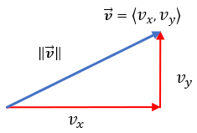

$$\left\|\vec{v}\right\|=\sqrt{{v_{x}}^{2}+{v_{y}}^{2}}$$

The vector $\vec{v}=\left\langle 2,\left.4\right\rangle \right.$ has magnitude

Example (1)

$\left\|\vec{v}\right\|=\sqrt{{v_{x}}^{2}+{v_{y}}^{2}}$

$\sqrt{2^{2}+4^{2}}= \sqrt{4+16}$ = $\sqrt{20}=2\sqrt{5}$

$\left\|\vec{v}\right\|=2\sqrt{5}$

Interpret this as the length of the vector $\vec{v}=\left\langle 2,\left.4\right\rangle \right.$ is $2\sqrt{5}$ units.

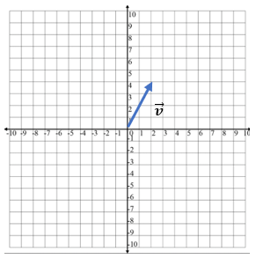

The formula for the length of the vector $\vec{v}=⟨v_{x}, v_{y},v_{z}⟩$ in **3-dimensions** is

$$\left\|\vec{v}\right\|=\sqrt{{v_{x}}^{2}+{v_{y}}^{2}+{v_{z}}^{2}}$$

The vector $\vec{v}=\left\langle 2,\left.4,-6\right\rangle \right.$ has magnitude $$\left\|\vec{v}\right\|=\sqrt{{v_{x}}^{2}+{v_{y}}^{2}+{v_{z}}^{2}}$$

Example (2)

$\left\|\vec{v}\right\|$ = ${\sqrt{2^{2}+4^{2}+\left(-6\right)}}^{2}$

$$\left\|\vec{v}\right\|= \sqrt{4+16+36}$$

$\left\|\vec{v}\right\|$ = $\sqrt{56}$

$$\left\|\vec{v}\right\|=2\sqrt{14}$$

Interpret this as the length of the vector $\vec{v}=\left\langle 2,\left.4,-6\right\rangle \right.$ is $2\sqrt{14}$ units.

## THE DIRECTION COSINES OF VECTORS IN 2- AND 3-DIMENSIONS

The direction cosines of a vector $\vec{v}=⟨v_{x}, v_{y}⟩$ or $\vec{v}=⟨v_{x}, v_{y},v_{z}⟩$ are the cosines of the angles the vector forms with the coordinate axes.

The direction cosines are important as they uniquely determine the direction of the vector.

Direction cosines are found by dividing each component of the vector by the magnitude (length) of the vector.

$cosα=\frac{v_{x}}{\left\|\vec{v}\right\|}$, $cosβ=\frac{v_{y}}{\left\|\vec{v}\right\|}$

$cosα=\frac{v_{x}}{\left\|\vec{v}\right\|}$, $cosβ=\frac{v_{y}}{\left\|\vec{v}\right\|}$, $cosθ=\frac{v_{z}}{\left\|\vec{v}\right\|}$

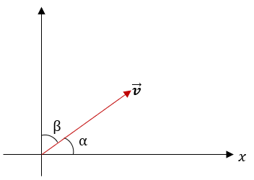 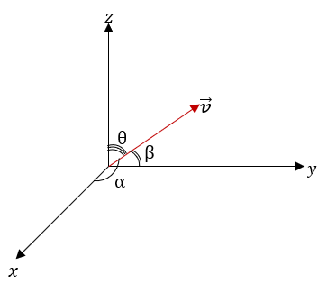

Find the direction cosines of the vector $\vec{v}=\left\langle 4,\left.5, 2\right\rangle \right.$.

Example (3)

First, find the magnitude of the vector $\vec{v}=\left\langle 4,\left.5, 2\right\rangle \right.$

$$\left\|\vec{v}\right\|=\sqrt{{v_{x}}^{2}+{v_{y}}^{2}+{v_{z}}^{2}}= \sqrt{4^{2}+5^{2}+2^{2}}= \sqrt{16+25+4}=\sqrt{45}=\sqrt{9×5}=3\sqrt{5}$$

Get the direction cosines by dividing each component, 4, 5, and 2, by this magnitude.

$$cosα=\frac{v_{x}}{\left\|\vec{v}\right\|}=\frac{4}{3\sqrt{5}} ≈0.596$$

$$cosβ=\frac{v_{y}}{\left\|\vec{v}\right\|}=\frac{5}{3\sqrt{5}} ≈0.745$$

$$cosθ=\frac{v_{z}}{\left\|\vec{v}\right\|}=\frac{2}{3\sqrt{5}} ≈0.298$$

Find the vector $\vec{v}$ that has magnitude 32 and direction cosines $cosα=5/8$

Example (4)

and $cosβ=-3/8$.

Since $cosα=\frac{v_{x}}{\left\|\vec{v}\right\|}and cosβ=\frac{v_{y}}{\left\|\vec{v}\right\|}$,

$v_{x}=\left\|\vec{v}\right\|∙cosα=32∙\frac{5}{8}=20$, and

$v_{y}=\left\|\vec{v}\right\|∙cosβ=32∙\frac{-3}{8}=-12$.

So, $\vec{v}=\left\langle 20,\left.-12\right\rangle \right.$.

## USING TECHNOLOGY

We can use technology to determine the magnitude of a vector.

Go to www.wolframalpha.com.

To find the magnitude of the vector $\vec{v}=\left\langle 2,\left.4, -6\right\rangle ,\right.$ enter magnitude of <2, 4, -6> in the entry field. Wolframalpha tells you what it thinks you entered, then tells you its answer. In this case, $\left\|\vec{v}\right\|=2\sqrt{14}$.

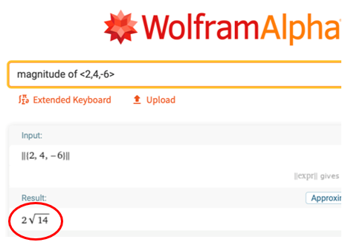

To find the direction cosines of the vector $\vec{v}=\left\langle 4,\left.5, 2\right\rangle ,\right.$ enter evaluate 4/(magnitude of <4,5,2>), 5/(magnitude of <4,5,2>), 2/(magnitude of <4,5,2>) in the entry field. WolframAlpha answers $\{0.596285, 0.745356, 0.298142\}$.

We can use WolframAlpha to approximate a vector give its magnitude and direction cosines.

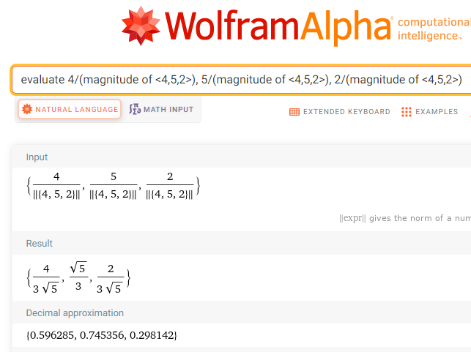

## EXAMPLES

1. Find the magnitude of the vector $\vec{v}=\left\langle -3, \left.4,-2\right\rangle \right..$

ANS: $\left\|\vec{v}\right\|=\sqrt{29}$

1. Find the magnitude of the vector $\vec{v}=\left\langle 1,\left.-1\right\rangle \right..$

ANS: $\left\|\vec{v}\right\|=\sqrt{2}$

1. Find the cosines of the vector $\vec{v}=\left\langle 3,\left.-1, 2\right\rangle \right.$. Round to three decimal places.

ANS: {0.802, -0.267, 0.535}

1. Approximate the vector $\vec{v}$ that has magnitude 24 and direction cosines $cosα=-3/4, cosβ=-1/4,cosθ=7/8$ 
   .

ANS: $<-18, -6, 21>$

## NOTE TO INSTRUCTOR

Consider presenting the formulas then working through these example problems.

1. Find the magnitude of the vector $\vec{v}=\left\langle 4,\left.1, -3\right\rangle \right.$.

ANS: $\left\|\vec{v}\right\|=\sqrt{26}$

1. Find the magnitude of the vector $\vec{v}=\left\langle 8,\left.-8\right\rangle \right.$.

ANS: $\left\|\vec{v}\right\|=8\sqrt{2}$

1. Find the direction cosines of the vector $\vec{v}=\left\langle 4,\left.1, -3\right\rangle \right.$. Round to three decimal places.

ANS: {0.784, 0.196, -0.588}

1. Approximate the vector $\vec{v}$ that has magnitude 30 and direction cosines $cosα=-3/5,$ $cosβ=-1/2, cosθ=7/10.$

ANS:

[3-2_magnitude_and_direction_cosines_of_a_vector_in_3-d.docx](https://oer4cte.org/math4gamedevelopers/teacher/3-2_magnitude_and_direction_cosines_of_a_vector_in_3-d.docx), attributed to Denny Burzynski (author) and Downey Unified School District (publisher) is licensed under CC BY-NC 4.0. To view a copy of this license, visit https://creativecommons.org/licenses/by-nc/4.0